British Universities Life Saving Clubs’ Association
Championships 2014 Entry Pack

December 2014
British Universities Life Saving Clubs’ Association
Written by Alexander Blandford

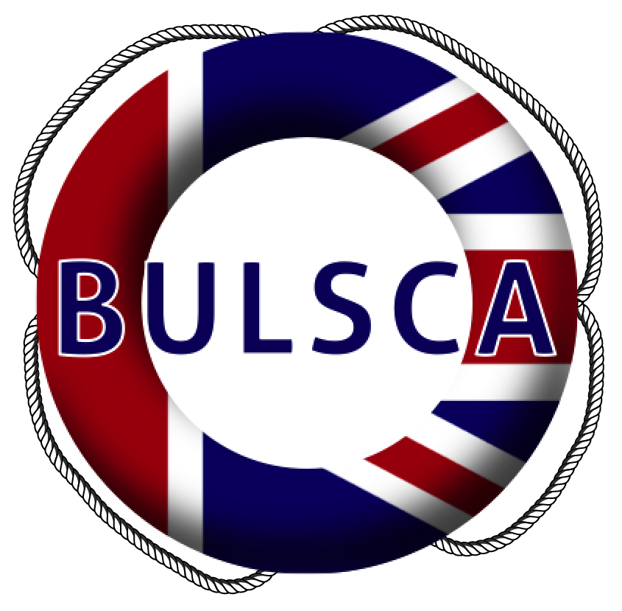
British Universities Life Saving Clubs’ Association
Championships 2014

Venue: University of Bath

Date: 15th - 16th March 2013

Registration: TBC

Championships Coordinator: Alexander Blandford
Championships@BULSCA.co.uk
£31.50 per person for Championships Squads
£16/£23 per person for up to 3/7 Individual Speed Events for the Student Speeds (Saturday)
£40 per four person team for the Student Nationals (Sunday)

Key dates
BULSCA_01 Squad entry | Friday 17th January 2014
BULSCA_02 Judges and Non Squad affiliated Helpers | Friday 31st January 2014
BULSCA_03 Equipment form | Friday 31st January 2014
BULSCA_04 Squad – Final names (including prerequisites) | Monday 24th February 2014
BULSCA_05 Individual speed entrant* | Monday 24th February 2014
BULSCA_06 Non Squad team entry (Student Nationals) † | Monday 24th February 2014
BULSCA_07 Young Person form*† | Monday 24th February 2014
BULSCA_08 Photography form*† | Monday 24th February 2014
BULSCA_09 Accommodation, T-Shirts and Food*† | Monday 24th February 2014
BULSCA_10 Reserve replacement | After Monday 24th February 2014
BULSCA_11 Speed Times – Final times*† | Sunday 9th March 2014
BULSCA_12 Student nationals – Final names† | Sunday 16th March 2014
BULSCA_13 Appeals form*† | Over the Championships weekend
BULSCA_14 Accident/Incident report*† | Over the Championships weekend
*Applicable to Individual Entrants (Saturday) †Applicable to Non-Squad Teams (Sunday)

British Universities Life Saving Clubs’ Association
Championships 2014

Form BULSCA_01 Squad entry
Please return to Alexander Blandford, championships@BULSCA.co.uk, by Friday 17th January 2014
Teams are charged at £31.50/person in a squad

Club name

Number in squad
Cheque/Transfer payment to BULSCA | £

Captain signature

Contact

Name

Email address

Phone number

Helpers
Each club/team should note that they must supply helpers as per rule 2.6 in the 2014 BULSCA Championships Rules and printed below.
These rules have changed since the 2013 BULSCA Championships.
2.6. Each participating Club must provide the services of helpers, bodies and timekeepers as per the Championships rules 2.6.1 and 2.6.2
2.6.1. Should a participating Club be competing in the Speeds, they must provide the services of at least one (1) non competing helper for the duration of the Speeds and one (1) Timekeeper per event for each event at the Speeds
2.6.1.1. The timekeeper provided for each event must not be competing in that event
2.6.1.2. At the discretion of Management the Timekeeper may be required to undertake other tasks helpful to the smooth running of the day
2.6.2. Should a participating Club be competing in the Nationals, they must provide the services of at least one helper and/or casualty per four (4) competitors for the duration of the Nationals
2.6.2.1. For the 4x12m Line Throw Relay and the 4x100m Swim and Tow Relay each club must provide the services of at least one (1) Timekeeper
2.6.3. Squads failing to meet this criterion may […] compete at the discretion of Management.

British Universities Life Saving Clubs’ Association
Championships 2014

Form BULSCA_02 Judges and Non Squad affiliated Helpers
Venue: University of Bath
Date: 15th-16th March 2014
Please return by Friday 31st January 2013 to Alexander Blandford, championships@BULSCA.co.uk

Name

Contact number

Email

Branch

University

(please list all Universities you are/have been affiliated with)

Judges – tick the applicable

Training a University team Judging at a local University competition
RLSS TA / S&S Instructor Judging at many University competitions
Medically Trained BULSCA Judge
Qualified Timekeeper RLSS Judge Branch
Qualified Starter Regional
National

Helpers - tick the applicable
University Life Saving club member/alumni
Frequent helper / body at Life Saving competitions
Infrequent/Non experienced helper/body

Availability
Saturday 15th March Registration
Speed Nationals
Sunday 16th March SERCs
Rope throw / Swim tow
Presentations

Additional Information
T-shirt size XS S M L XL
Vegetarian

British Universities Life Saving Clubs’ Association
Championships 2014

Form BULSCA_03 Equipment form
Please return to Alexander Blandford, championships@BULSCA.co.uk, by Friday 31st January 2014:

Contact

Name

Club name

Email address

Phone number

Please state all equipment that is owned by your club.
Please also indicate what equipment you will be able to bring with respect to your planned travel arrangements.
 | Owned |  | Able to bring currently
Equipment available | Number | Dimensions | Number | Dimensions
Orange Manikins w. 3 bungs |  | - |  | -
Yellow ILS tube |  | - |  | -
16-18m Rope |  | - |  | -
Gates |  | 210cm x 70cm |  | 210cm x 70cm
Rigid crossline |  | 17m |  | 17m
Stopwatches |  | - |  | -
Handheld Radio |  | - |  | -

British Universities Life Saving Clubs’ Association
Championships 2014

Forms BULSCA_04 Squad – Final names
Final names to be added to a form on www.BULSCA.co.uk.
Please return to Alexander Blandford, championships@BULSCA.co.uk by Monday 24th February 2014
Reserves must also be specified by this date in order to be eligible for use as replacement competitors. Up to one (1) Reserve is permitted per Male and Female Squad. Reserves for the Male Squad may be of either sex.
Times may be added until 9th March 2014.

Competitors
Each competitor must hold a valid qualification for the duration of the Championships (Please see the Championships Rules 2014 for a list of valid qualifications). Proof of this must be emailed to Alexander Blandford, championships@BULSCA.co.uk, by Monday 24th February 2014
Each competitor must be eligible to participate at BULSCA competitions as detailed in section 6.2 of the BULSCA Constitution v2.2. Proof of this must be emailed to Alexander Blandford, championships@BULSCA.co.uk, by Monday 24th February 2014. (Examples of proof include: a student card; a proof of Student Status Letter from your university along with photo ID such as a driving license/passport – Some form of photographic ID must be included)

Helpers
Each club/team must supply helpers as per rule 2.6 in the 2014 BULSCA Championships Rules. Please complete the information below, indicating their availability for each day and return to Alexander Blandford, championships@BULSCA.co.uk by Monday 24th February 2014.
Name and email address of helper(s) as applicable | Exp* | Sat | Sun

1.

2.

3.

4.

5.

6.
*Please indicate whether the helper has previous experience helping/bodying at life saving competitions

British Universities Life Saving Clubs’ Association
Championships 2014

Forms BULSCA_05 Individual Speeds entrant
Please return by Monday 24th February 2014 to Alexander Blandford, championships@BULSCA.co.uk Individual competitors will be dealt with on a first come, first serve basis. Entry times may be submitted up to the 10th of March 2014.
The Championships Coordinator reserves the right not to accept your entry in exceptional circumstances.
Individuals are charged at £16 to compete in (up to) 3 events or £23 to compete in (up to) 7 events

Contact

Name

Club name

Email address

Phone number

Events
Please rank the events you would like to compete in (1-7, 1= Most like to compete in):

Obstacle swim 200m

Manikin carry 50m

Rescue medley 100m

Manikin Carry with fins 100m

Manikin Tow with fins 100m

Super Lifesaver 200m

Line Throw

Each competitor must hold a valid qualification for the duration of the Championships (Please see rules for a list of valid qualifications). Proof of this must be emailed to Alexander Blandford, by Monday 24th February 2014.
To be eligible to hold Student records you must fulfil the eligibility criteria as detailed in section 6.2 of the BULSCA Constitution v2.2 (if you have any questions regarding your eligibility please contact Alexander Blandford). Proof of this must be emailed to Alexander Blandford, by Monday 24th February 2014. (Examples of proof include: a student card; a proof of Student Status Letter from your university along with photo ID such as a driving license/passport– Some form of photographic ID must be included).

British Universities Life Saving Clubs’ Association
Championships 2014

Forms BULSCA_06 Non Squad team entry (Student Nationals)
Please return to Alexander Blandford, championships@BULSCA.co.uk by Monday 24th February 2014
Non Squad teams will be dealt with on a first come, first serve basis. Entry times for the Swim & Tow may be submitted up to the 10th of March 2014 by email to Alexander Blandford if not completed below.
The Championships Coordinator reserves the right not to accept your entry in exceptional circumstances.
Teams are charged at £40 per team

Club name

Club contact signature
No. teams required (Please circle) | A Team | B Team | C Team

4x100m Swim & Tow Relay time

Helpers
Each four person team must supply a helper/body for the day as per rule 2.6 in the 2014 BULSCA Championships Rules. Please complete the below with the relevant information. Should you have any concerns regarding supplying a helper for the day please contact Alexander Blandford.
Name and email address of helper(s) as applicable | Exp*

1.

2.

3.
*Please indicate whether the helper has previous experience helping/bodying at life saving competitions

Each competitor must hold a valid qualification for the duration of the Championships (Please see rules for a list of valid qualifications). Proof of this must be emailed to Alexander Blandford, by Monday 24th February 2014.
To be eligible to hold Student records each team member must fulfil the eligibility criteria as detailed in section 6.2 of the BULSCA Constitution v2.2 (if you have any questions regarding your eligibility please contact Alexander Blandford). Proof of this must be emailed to Alexander Blandford, by Monday 24th February 2014. (Examples of proof include: a student card; a proof of Student Status Letter from your university along with photo ID such as a driving license/passport – Some form of photographic ID must be included).
British Universities Life Saving Clubs’ Association
Championships 2014

Forms BULSCA_07 Young person – under 18 years
To be completed by a parent/guardian:
Please return to Alexander Blandford, championships@BULSCA.co.uk, by Monday 24th February 2014
Individual competitors will be dealt with on a first come, first serve basis.

Contact

Name

Club name

Email address

Date of Birth

Supervisor/Coach details (to be present at the event)

Name

Relation to the individual

Email address

Phone number

I give permission for the individual named to engage in the BULSCA National Championships on the 15th and 16th March 2014. The individual will be representing their Life saving Club.
Please indicate that you consent the individual to attend the following sections of the Championships. Your signature indicates that you are aware of the risks that are present and have advised the individual to minimise any danger. Any behaviour or incident involving the individual shall be responsibility of the individual and the Life saving club they represent.

Student speeds

Evening social

Student Nationals

I understand that the individual is less than 18 years old, and will have an adult to supervise them at all times, as stated in the Royal Life Saving Society Child Protection guidelines.
Parent/Guardian Print Name:
Signed:
Date:
A signed copy must be brought to the Competition
British Universities Life Saving Clubs’ Association
Championships 2014

Forms BULSCA_08 Photography permission
Please return to Alexander Blandford, championships@BULSCA.co.uk by Monday 24th February 2014
One form to be completed by each squad/team (unless containing competitors under 18 where a separate form per competitor is required. In this case please return the form by the date above, ensuring parent/guardian signed copies are brought to the competition).
As part of our communication activity, BULSCA occasionally uses photography for publicity purposes. You give your permission for photographs or film of yourself or your club members, to be taken for the inclusion on and in our publications, website and other publicity material. The images will remain the property of BULSCA, and will be used for the designated purpose of promoting BULSCA and raising awareness of the sport.

Name

Club name

Email address
I allow BULSCA to hold and distribute photos and film as part of publications, as stated above, which may contain the individual listed.
Signed:
Date:
Young Person – under 18
If the participant is under 18 years, a parent or guardian should complete the following:

Young Person Name

Young Person Date of birth

Name of parent or guardian

Contact email/phone number
I allow BULSCA to hold and distribute photos and film as part of publications, as stated above, which may contain the individual listed.
Parent/Guardian Signature:
Date:
A signed copy must be brought to the competition
British Universities Life Saving Clubs’ Association
Championships 2014

Forms BULSCA_09 Accommodation, T-Shirts and Food
Please return to Alexander Blandford, championships@BULSCA.co.uk by Monday 24th February 2014
Please complete the below for your club (or individual if applicable) including helpers

Name

Club name

Email address

Phone number

Accommodation
Please note we are unable to host any under 18s. If this is an issue please contact Alexander Blandford

Number requiring accommodation on Friday night

Number requiring accommodation on Saturday night

T-Shirts
Please note the sizes below relate to standard Men’s/Unisex T-Shirts
 | Competitors | Helpers

Number of XS T-Shirts Required

Number of S T-Shirts Required

Number of M T-Shirts Required

Number of L T-Shirts Required

Number of XL T-Shirts Required

Food
 | Vegetarian | Non-Vegetarian

Number requiring food (Sat evening only)

British Universities Life Saving Clubs’ Association
Championships 2014

Form BULSCA_10 Reserve replacement
To be used from Monday 24th February 2014.

Club name

Reserve competitor

Competitor to be replaced

Reserves must have been specified before Monday 24th of February 2014 in order to be eligible as replacement competitors.

The Rules governing the use of Reserves, and the effect of this on a Club’s scoring, can be found in section 3 of the Championships Rules 2014. These Rules vary depending on the time, relative to the Championships, at which the use of a Reserve is requested. Please read them carefully.

British Universities Life Saving Clubs’ Association
Championships 2014

Forms BULSCA_11 Squad – Final times
Final times to be added to a form on www.BULSCA.co.uk.
Please complete by Sunday 9th March 2014.

British Universities Life Saving Clubs’ Association
Championships 2014

Forms BULSCA_12 Student nationals – Final names
Please complete by Sunday 16th March 2014.

Squad name

Squad contact signature

No. in squad

Teams must comply with the rules stated in the 2013-14 BULSCA Competition Manual, and must be made up of individuals who participated in the Student Speed Nationals.
A Team | C
A Team | 2
A Team | 3
A Team | 4
B Team | C
B Team | 2
B Team | 3
B Team | 4
C Team | C
C Team | 2
C Team | 3
C Team | 4

British Universities Life Saving Clubs’ Association
Championships 2014

Forms BULSCA_13 Appeals form

Please use the appeals form in the current BULSCA competition manual.
British Universities Life Saving Clubs’ Association Championships 2014

Form BULSCA_14 Accident / incident report

Name of person involved in accident / incident

Address of person involved in accident / incident

Date of accident / incident

Area incident occurred in

Incident that occurred

Extent of accident / incident

Who was contacted?

Witness

How could it be avoided?
If you require more space please continue on a separate sheet.

Signed:
Date:

